Friday
Doubling
Warm up
- Running and jumping whilst counting forwards/backwards to 20 and beyond.
- Practise doubles using the interactive game https://www.ictgames.com/mobilePage/archeryDoubles/index.html
Activities

Watch the doubling video
https://www.youtube.com/watch?v=8jOzhiACB68

Practise rapid recall of the doubles facts e.g. Tell me double 2. What is double 4? You can use fingers to show this.

Explain that when we double a number we are adding the same number again. For example, double 2 means 2 add 2 more. Double 4 is 4 add 4 again.

Make a large ‘ladybird’ using red paper or a plate. On one half of the ladybird place black spots (or use raisins). Then match the dots on the other side to find double that number. Write the number sentence e.g. 2 + 2 = 4.
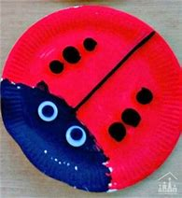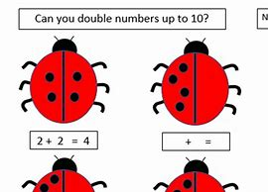
You could also try these activities here: https://www.twinkl.co.uk/resource/t-c-254576-ladybird-doubles-to-20-activity-sheet

Finish by watching the numberblocks doubling video https://www.youtube.com/watch?v=Bot83VxMLqM

